**Earthquake Engineering homework2**

土木碩一 11372009 邱昱倫

1. **Plot the ground motion history of Northridge earthquake and find the maximum acceleration value.**

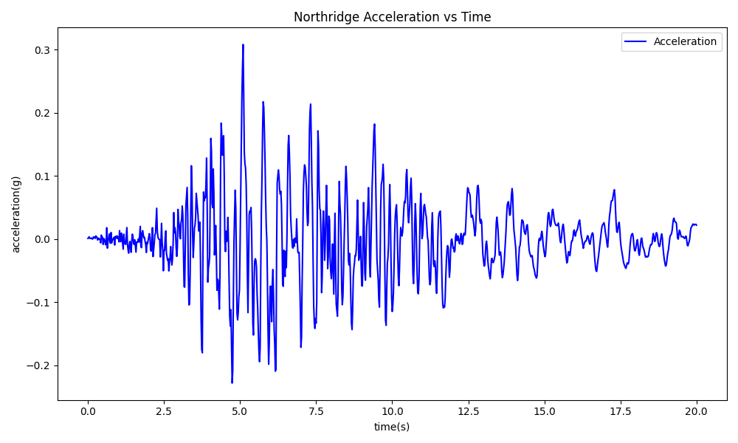

Peak Ground Acceleration = 0.3079(g)

1. **Calculate k and T in N-S and E-W directions**

M = 290/386.09 = 0.751 kpounds

$$k_{NS} = \frac{3EI}{L^{3}}*24= \frac{3*29000*209}{{(14*12)}^{3}}*24=92.03$$

$$k_{EW} = \frac{EA}{L}{(cos{θ})}^{2}*6= \frac{29000*0.785}{28.65*12}*{\left(\frac{25}{28.65}\right)}^{2}*6=302.51$$

$$ω_{NS}= \sqrt{\frac{k_{NS}}{M}}=\sqrt{\frac{92.03}{0.751}}=11.07 ; T_{NS}=\frac{2π}{ω_{NS}}=0.567(s)$$

$ω_{EW}=\sqrt{\frac{k_{EW}}{M}}=\sqrt{\frac{302.51}{0.751}}=20.07 ;T_{EW}=\frac{2π}{ω_{EW}}=0.313(s)$

1. **and 4. plot x(t)、x’(t)、x’’(t) in N-S and E-W directions and find the maximum**

|  |  |
| --- | --- |
| N-S direction | E-W direction |
| 一張含有 文字, 字型, 繪圖, 螢幕擷取畫面 的圖片  AI 產生的內容可能不正確。 | 一張含有 文字, 繪圖, 螢幕擷取畫面, 圖表 的圖片  AI 產生的內容可能不正確。 |
| 一張含有 文字, 行, 繪圖, 圖表 的圖片  AI 產生的內容可能不正確。 | 一張含有 文字, 繪圖, 螢幕擷取畫面, 圖表 的圖片  AI 產生的內容可能不正確。 |
| 一張含有 文字, 繪圖, 螢幕擷取畫面, 行 的圖片  AI 產生的內容可能不正確。 | 一張含有 文字, 繪圖, 螢幕擷取畫面, 圖表 的圖片  AI 產生的內容可能不正確。 |

**5. determine the V(t)max and M(t)max in N-S direction**

According to the result of average acceleration method, we get the maximum displacement response of the structure.

|  |  |
| --- | --- |
| N-S | response spectra |
| maximum u(inch) | 1.9484 |
| maximum v (inch/s) | 22.2538 |
| maximum a (inch/s2) | 265.2481 |

Therefore, V(t)max of each column can be determined.

$$V_{max}=\frac{k_{NS}}{24}*{x\left(t\right)}_{max}=\frac{92.03}{24}*1.9484= 7.471(kip)$$

And the maximum moment of each column is:

$$M_{max}=V_{max}*h=7.471*14=104.60 (kip-ft)$$

**6. determine the V(t)max and P(t)max in E-W direction**

Same as the last question, we get the table by applying the average acceleration method.

|  |  |
| --- | --- |
| E-W | response spectra |
| maximum u(inch) | 0.8195 |
| maximum v(inch/s) | 14.5532 |
| maximum a(inch/s2) | 303.2666 |

The V(t)max in each bracing can be calculated:

$$V_{max}=\frac{k_{EW}}{6}*{x\left(t\right)}_{max}=\frac{302.51}{6}*0.8195= 41.318(kip)$$

However, to acquire the maximum normal stress P(t)max, we should divide the cosine components:

$$P_{max}=\frac{V_{max}}{{(cos{θ})}^{2}}=\frac{41.318}{{\left(\frac{25}{28.65}\right)}^{2}}=54.263 (kip)$$

**7. Find Sd、Spv、Spa 、V(t)max、and M(t)max of the SDOF system in N-S direction**

According to Fig 18.21(Newmark-Hall broad-banded design spectra)

We know that *TNS* = 0.567 (s) and by searching Fig 18.21, we can get that:

*Sd* = 2.2 (inch)

*Spv* = 26.2(inch/s)

*Spa* = 0.74 (g) = 0.74 * 386.09 =285.71 (inch/s2)

Accordingly, the *V(t)max* and *M(t)max* can be determined as follows:

$$V_{max}=\frac{k_{NS}}{24}*{x\left(t\right)}_{max}=\frac{92.03}{24}*2.2= 8.436 (kip)$$

$$M_{max}=V_{max}*h=8.436*14=118.105 (kip-ft)$$

**8. Find Sd、Spv、Spa 、V(t)max、and P(t)max of the SDOF system in**

**E-W direction**

We know that *TEW* = 0.313 (s) and by searching Fig 18.21, we can get that:

*Sd* = 0.6 (inch)

*Spv* = 15.6(inch/s)

*Spa* = 0.74 (g) = 0.74 * 386.09 =285.71 (inch/s2)

Accordingly, the *V(t)max* and *M(t)max* can be determined as follows:

$$V_{max}=\frac{k_{EW}}{6}*{x\left(t\right)}_{max}=\frac{302.51}{6}*0.6= 30.251 (kip)$$

$$P_{max}=\frac{V_{max}}{{(cos{θ})}^{2}}=\frac{30.251}{{\left(\frac{25}{28.65}\right)}^{2}}=39.729 (kip)$$

**9. Compare results from response spectra with design spectra.**

|  |  |  |  |
| --- | --- | --- | --- |
| N-S | response spectra | design spectra | relative error |
| umax(inch) | 1.9484 | 2.2 | 11.44% |
| vmax(inch/s) | 22.2538 | 26.2 | 15.06% |
| amax(inch/s2) | 265.2481 | 285.7066 | 7.16% |
| E-W |  |  |  |
| umax(inch) | 0.8195 | 0.6 | 36.58% |
| vmax(inch/s) | 14.5532 | 15.6 | 6.71% |
| amax(inch/s2) | 303.2666 | 285.7066 | 6.15% |

Vmax and Mmax are proportional to umax so relative error of Vmax and Mmax of response spectra and design spectra will be 11.44% for N-S direction and 36.58% for E-W direction.